McPherson County

Child Care Task Force
Tuesday 06.20.2023 4:00 PM
(third Tuesday of even months)
─
McPherson County Community Foundation Child Care Task Force seeks to understand the multifaceted hardships of the child care system in McPherson County. In hopes that in more fully understanding the problem we can more efficiently and effectively impact positive change.

Attendees
Jenn Burgardt, Betsy Davis, Tom Brown, Austin Regier, Debbie Hawkinson, Shalei Shae (zoom), Casie Wiens (zoom), Ron Peters, Katie Walters, Christy Carlson

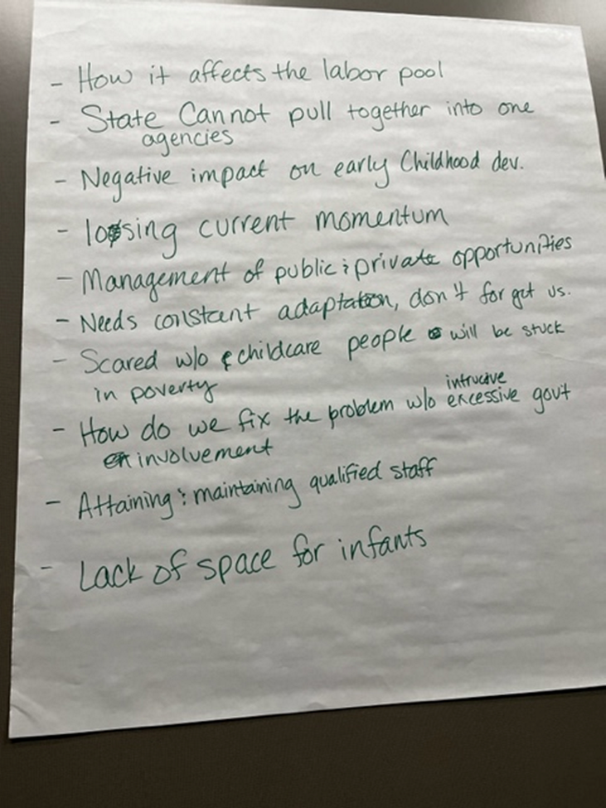
Agenda

Introductions and Powerful Question

What worries you most about child care in McPherson County?

Last Meeting Follow-up
- PTO connection to host Family Focus Groups-Status
  - September/ Early Fall plan to have Focus Groups at school facilitated in conjunction with Parent teacher organizations. Hope to get variety of parents, teachers, organizations present
    - Lots of dates and personal invites.

- Child Care Aware of Kansas Community Partnership Grant Updates
  - Funding Initiatives
    - $10,000 Available to Child Care Programs for Initial Project Expenses
    - Provider Event in August or September
      - KDHE hrs will be offered in partnership with CCAKS/KCCTO
      - Providers will partake in exploring ideas and creating innovative strategies and offerings for shared services network
    - Marketing and Networking with State of Child Care in McPherson County Task Force Infographic

- All In For Kansas Kids Child Care Accelerator Grant General Updates- We will learn Jun 23, 2023 if we received funding for McPherson County’s projects

- McPherson County Community Child Care Capacity Building Updates
  - Duplexes or Church Renovation
    - Had a hiccup on the McPherson projects not being what the grant administrators were looking for
  - Possibly have a home daycare provider possibly move into the renovated facility. Mayor Brown will follow up with the church.
    - Assistance with drawings utilizing CCKS grant award
  - Explore Headstart/Earlyhead start option?
    - Has been a concern about competition with providers. Will need to do more research on possible impact
  - Lindsborg Project
    - Child Care Accelerator Grant Expansion Project submitted with help from LeighAnn Montoy/licensing surveyor
  - Moundridge Project
    - Working on plans for new build utilizing gifted land from USD 423

  - Inman Project
    - Before and after school program
—-Question about if the city has ever had subsidized care? Right now there is a program for McPherson families on free lunches for $1500 per month. How can it be duplicated in other cities? **Great to share at the Early child care transitions roadshow in Salina June 24 at 5**

New Business
- Child Care Aware of Kansas Shared Services Application. Looking at providing services to decrease administrative time and cost for providers
- Child Care Tax Credit for Businesses- as far as we know these will be available again. Announced amount last year on July 1, will look for update then
  - Investor tax credit for child care just like for housing. Builder can put in for an investor tax credit through the state, Investment Historical tax credit- could this type program be adapted for childcare?

Notes/Resources
- 2022 Assessing the Child Care Landscape Supply Demand Report
- ECE Resources Kansas
- https://online.flippingbook.com/view/1037794395/20/

Action Items
- Attend child care task for road show in Salina June 28
- Continue to be child care advocate

Next Meeting Agenda Items
- Accelerator grant results
- Shared Service Hub FRA update

Next Meeting Date: August 22, 2023

