Community Coalition meeting

January 23, 2025

Welcome

1. Introductions- On a Scale of Chicken How are you feeling today

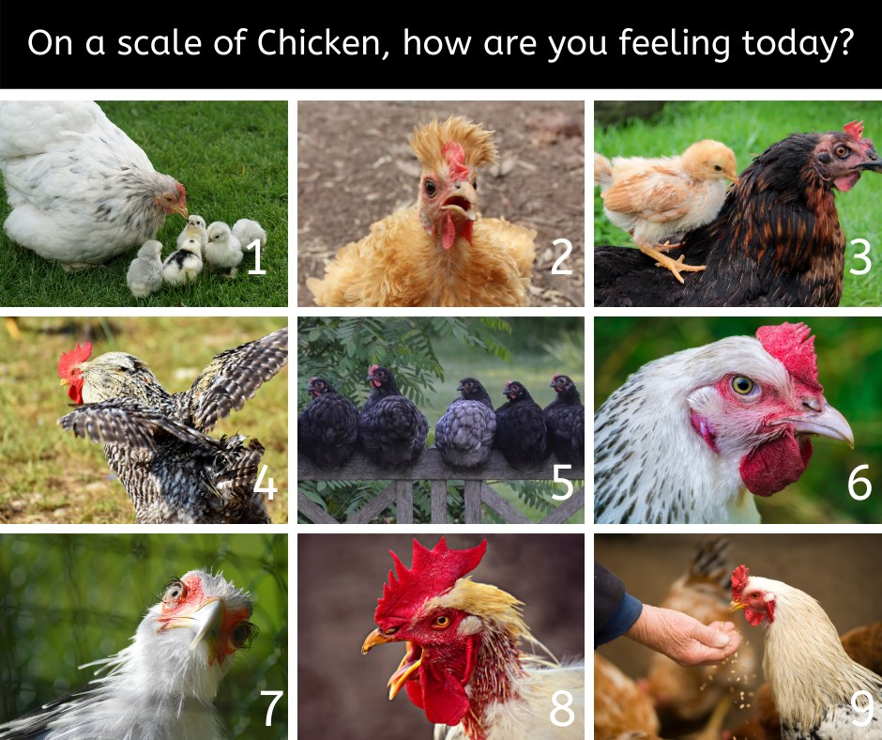

Arlo Blevins, Michelle Huddle, Debbie Gieselman, , Betsy Davis, Hayley Pavlovich, DArcie Weiser, Angela Brunk, Andi Amann, Leslie Guinn, Lara Vanderhoof, Laura Parks, Kieryn McCann, Jackie Gilby, Chris Fantastic

1. Community Successes!
   1. STEP Mc- 81-93 adults 65-70 kids out of Poverty in 2024
   2. Getting Ahead while getting out- Step MC/Jail collaboration
   3. DAA starting saturday, NAA in the jail as well
   4. PrairieView- assessments for Drug related recidivism and support after release
   5. Positive interaction with MPD
   6. Drug Court will be launching in March!
   7. MCEID now has an office at McPherson Makers space
2. VITA-
   1. Volunteer income Tax Assistance February and March
      1. Helps families $67,000 or less file taxes
         1. Monday evenings, Tuesday and Thursday afternoons, 2 Saturdays
      2. Well send out flyer to organizations soon
3. Neighboring Movement
   1. Teaching us how to be better neighbors.
   2. Neighbors are an asset and support system
   3. Focuses on what is strong not what is wrong
   4. Rural Cohort starting in June
4. Child Care Professional Learning Communities
   1. April
5. Mastermind Year 3
   1. March
6. Resource Council Christmas- update
   1. [Julie Johnson](mailto:juliejohnsonphotographyks@gmail.com)Christmas stockings for Moms
   2. MCEID- gift wrapping
7. Immediate needs or concerns?
   1. Hydroponics- Shane Kirshner at McPherson College
   2. additional Oxford house on the horizons will need household items
   3. Week of the young child coming up. Apr 11, 2025
   4. Maker Space has ceramic molds they are looking to get rid of
   5. United Way completing their Campaign on January 31
8. Upcoming events
   1. Human Trafficking Seminar February 13
   2. Grant Writing Seminar February 27
   3. Match Week March 3-7
   4. Next Grant Cycle is due March 15, 2025
   5. LIEP open dates through March 31, 2025
      1. At MPL February 25, 2025
   6. Rural Cohort Neighboring Movement June 2025
9. Dismiss

Next Coalition meeting will be March 27, 2025